**MBAN 5220 Assignment 3**

**Chapter 6 Level I Exercises**

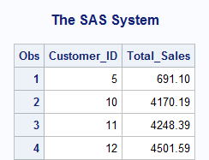1 a)

/* Program with a logic error */

**data** customers;

set orion.order_summary;

by Customer_ID;

if first.Customer_ID=**1** then TotSales=**0**;

Total_Sales+Sale_Amt;

if last.Customer_ID=**1**;

keep Customer_ID Total_Sales;

**run**;

**proc** **print** data=customers;

**run**;

c)

/* Program with a logic error */

**data** customers;

set orion.order_summary;

by Customer_ID;

if first.Customer_ID=**1** then TotSales=**0**;

/* Display TotSales and Sale_Amt */

putlog TotSales= Sale_Amt=;

Total_Sales+Sale_Amt;

/* Display Total_Sales */

putlog Total_Sales=;

if last.Customer_ID=**1**;

keep Customer_ID Total_Sales;

**run**;

TotSales=0 Sale_Amt=478

Total_Sales=478

TotSales=. Sale_Amt=126.8

Total_Sales=604.8

TotSales=. Sale_Amt=52.5

Total_Sales=657.3

TotSales=. Sale_Amt=33.8

Total_Sales=691.1

TotSales=0 Sale_Amt=32.6

Total_Sales=723.7

TotSales=. Sale_Amt=250.8

Total_Sales=974.5

1 d)

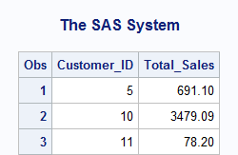**data** customers;

set orion.order_summary;

by Customer_ID;

if first.Customer_ID=**1** then Total_Sales=**0**;

Total_Sales+Sale_Amt;

if last.Customer_ID=**1**;

keep Customer_ID Total_Sales;

**run**;

/* Print the output data set */

**proc** **print** data=customers;

**run**;

**Chapter 7 Level I and II Exercises**

1 a)

**data** future_expenses;

drop start stop;

Wages=**12874000**;

Retire=**1765000**;

Medical=**649000**;

start=year(today())+**1**;

stop=start+**9**;

do Year=start to stop;

wages=wages\***1.06**;

retire=retire\***1.014**;

medical=medical\***1.095**;

Total_Cost=sum(wages,retire,medical);

output;

end;

**run**;

NOTE: The data set WORK.FUTURE_EXPENSES has 10 observations and 5 variables.

NOTE: DATA statement used (Total process time):

real time 0.03 seconds

cpu time 0.01 seconds

1 b)

**proc** **print** data=future_expenses;

format wages retire medical total_cost comma14.2;

var year wages retire medical total_cost;

**run**;

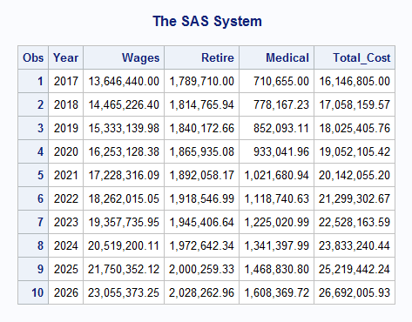

2 a)

**data** income_expenses;

Wages=**12874000**;

Retire=**1765000**;

Medical=**649000**;

Income=**50000000**;

Year=year(today())+**1**;

do until (Total_Cost > Income);

wages = wages * **1.06**;

retire=retire\***1.014**;

medical=medical \***1.095**;

Total_Cost=sum(wages,retire,medical);

Income=Income \***1.01**;

output;

year+**1**;

end;

**run**;

NOTE: The data set WORK.INCOME_EXPENSES has 26 observations and 6 variables.

NOTE: DATA statement used (Total process time):

real time 0.01 seconds

cpu time 0.00 seconds

b)

**proc** **print** data=income_expenses;

format total_cost income comma14.2;

var year income total_cost;

**run**;

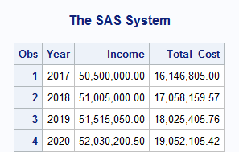

3 a)

**data** expenses;

Income= **50000000**;

Expenses = **38750000**;

do Year=**1** to **30** until (Expenses > Income);

income+(income * **.01**);

expenses+(expenses * **.02**);

end;

**run**;

NOTE: The data set WORK.EXPENSES has 1 observations and 3 variables.

NOTE: DATA statement used (Total process time):

real time 0.01 seconds

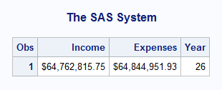 cpu time 0.00 seconds

b)

**proc** **print** data=expenses;

format income expenses dollar15.2;

**run**;

5 a)

**data** discount_sales;

set orion.orders_midyear;

array mon{*} month1-month6;

drop i;

do i=**1** to **6**;

mon{i} = mon{i} \***.95**;

end;

**run**;

NOTE: Missing values were generated as a result of performing an operation

on missing values.

Each place is given by: (Number of times) at (Line):(Column).

56 at 157:23

NOTE: There were 24 observations read from the data set ORION.ORDERS_MIDYEAR.

NOTE: The data set WORK.DISCOUNT_SALES has 24 observations and 7 variables.

NOTE: DATA statement used (Total process time):

real time 0.03 seconds

cpu time 0.04 seconds

5 b)

title 'Monthly Sales with 5% Discount';

**proc** **print** data=discount_sales noobs;

format month1-month6 dollar10.2;

**run**;

title;

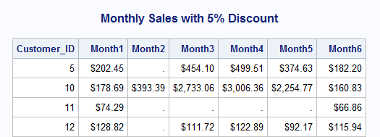

6 a)

**data** special_offer;

set orion.orders_midyear;

array mon{*} month1-month3;

keep Total_Sales Projected_Sales Difference;

Total_Sales=sum(of month1-month6);

do i=**1** to **3**;

mon{i} = mon{i} \***.90**;

end;

Projected_Sales=sum(of month1-month6);

Difference=Total_Sales-Projected_Sales;

**run**;

NOTE: Missing values were generated as a result of performing an operation

on missing values.

Each place is given by: (Number of times) at (Line):(Column).

28 at 174:23

NOTE: There were 24 observations read from the data set ORION.ORDERS_MIDYEAR.

NOTE: The data set WORK.SPECIAL_OFFER has 24 observations and 3 variables.

NOTE: DATA statement used (Total process time):

real time 0.02 seconds

cpu time 0.03 seconds

6 b)

options nodate nonumber;

title 'Total Sales with 10% Discount in First Three Months';

**proc** **print** data=special_offer noobs;

format total_sales projected_sales difference dollar10.2;

sum difference;

**run**;

title;

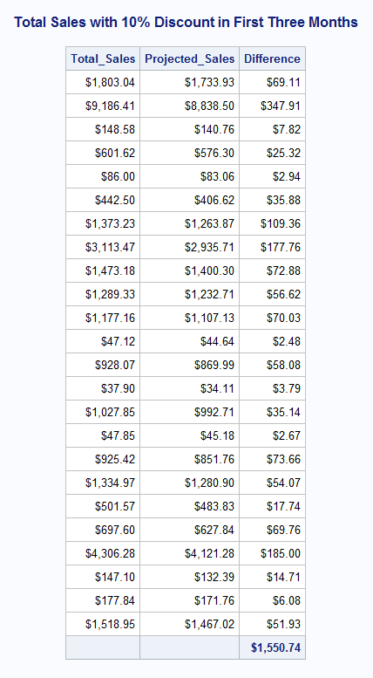

8 a)

**data** preferred_cust;

set orion.orders_midyear;

array Mon{**6**} Month1-Month6;

keep Customer_ID Over1-Over6 Total_Over;

array Over{**6**};

array Target{**6**} _temporary_ (**200**,**400**,**300**,**100**,**100**,**200**);

do i=**1** to **6**;

if Mon{i} > Target{i} then

Over{i} = Mon{i} - Target{i};

end;

Total_Over=sum(of Over{*});

if Total_Over > **500**;

**run**;

NOTE: Missing values were generated as a result of performing an operation

on missing values.

Each place is given by: (Number of times) at (Line):(Column).

8 at 203:15

NOTE: There were 24 observations read from the data set ORION.ORDERS_MIDYEAR.

NOTE: The data set WORK.PREFERRED_CUST has 9 observations and 8 variables.

NOTE: DATA statement used (Total process time):

real time 0.01 seconds

cpu time 0.00 seconds

b)

**proc** **print** data=preferred_cust noobs;

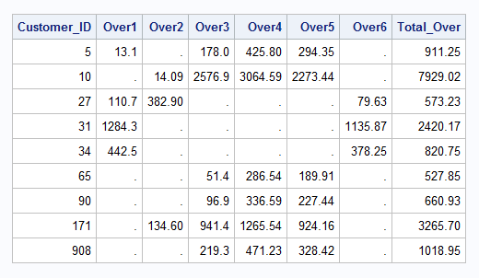**run**;

9 a)

**data** passed failed;

set orion.test_answers;

drop i;

array Response{**10**} Q1-Q10;

array Answer{**10**} $ **1** _temporary_ ('A','C','C','B','E',

'E','D','B','B','A');

Score=**0**;

do i=**1** to **10**;

if Answer{i}=Response{i} then Score+**1**;

end;

if Score ge **7** then output passed;

else output failed;

**run**;

NOTE: There were 15 observations read from the data set ORION.TEST_ANSWERS.

NOTE: The data set WORK.PASSED has 12 observations and 12 variables.

NOTE: The data set WORK.FAILED has 3 observations and 12 variables.

NOTE: DATA statement used (Total process time):

real time 0.06 seconds

cpu time 0.00 seconds

b)

title 'Passed';

**proc** **print** data=passed;

**run**;

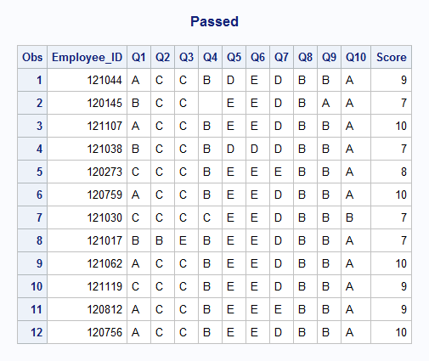

9 c)

title 'Failed';

**proc** **print** data=failed;

**run**;

title;

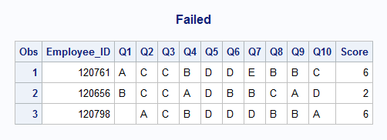

**Chapter 8 Level I and II Exercises**

1 a)

**data** sixmonths;

set orion.orders_midyear;

keep customer_id month sales;

array months{**6**} month1-month6;

do Month=**1** to **6**;

if months{Month} ne **.** then do;

Sales=months{Month};

output;

end;

end;

**run**;

NOTE: There were 24 observations read from the data set ORION.ORDERS_MIDYEAR.

NOTE: The data set WORK.SIXMONTHS has 88 observations and 3 variables.

NOTE: DATA statement used (Total process time):

real time 0.01 seconds

cpu time 0.00 seconds

b)

title 'Customer Sales';

**proc** **print** data=sixmonths;

**run**;

title;

NOTE: There were 88 observations read from the data set WORK.SIXMONTHS.

NOTE: PROCEDURE PRINT used (Total process time):

real time 0.48 seconds

cpu time 0.14 seconds

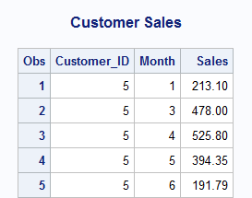

2 a)

**data** travel;

set orion.travel_expense;

keep employee_id trip_id Expense_Type amount;

array exp{**5**} exp1-exp5;

array descr{**5**} $ **14** _temporary_

('Airfare','Hotel','Meals','Transportation','Miscellaneous');

do i=**1** to **5**;

if exp{i} ne **.** then do;

Expense_Type=descr{i};

Amount=exp{i};

output;

end;

end;

**run**;

NOTE: There were 10 observations read from the data set ORION.TRAVEL_EXPENSE.

NOTE: The data set WORK.TRAVEL has 44 observations and 4 variables.

NOTE: DATA statement used (Total process time):

real time 0.03 seconds

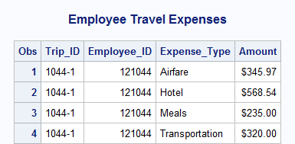 cpu time 0.01 seconds

b)

title 'Employee Travel Expenses';

**proc** **print** data=travel;

format Amount dollar8.2;

**run**;

title;

**Chapter 9 Level I and II Exercises**

1 a)

**data** revenue

NotSold(keep=Price Product_ID Product_Name)

InValidCode(Keep=Product_ID Quantity Customer);

merge orion.web_products(in=InProduct) orion.web_orders(in=InOrders);

by Product_ID;

if InProduct and InOrders then do;

Revenue = Quantity * Price;

output revenue;

end;

else if InProduct and not InOrders then output notsold;

else if not InProduct and InOrders then output invalidcode;

**run**;

NOTE: There were 20 observations read from the data set ORION.WEB_PRODUCTS.

NOTE: There were 43 observations read from the data set ORION.WEB_ORDERS.

NOTE: The data set WORK.REVENUE has 39 observations and 6 variables.

NOTE: The data set WORK.NOTSOLD has 7 observations and 3 variables.

NOTE: The data set WORK.INVALIDCODE has 4 observations and 3 variables.

NOTE: DATA statement used (Total process time):

real time 0.07 seconds

cpu time 0.03 seconds

b)

title 'Revenue from Orders';

**proc** **print** data=revenue noobs;

**run**;

title 'Products Not Ordered';

**proc** **print** data=notsold noobs;

**run**;

title 'Invalid Orders';

**proc** **print** data=invalidcode noobs;

**run**;

title;

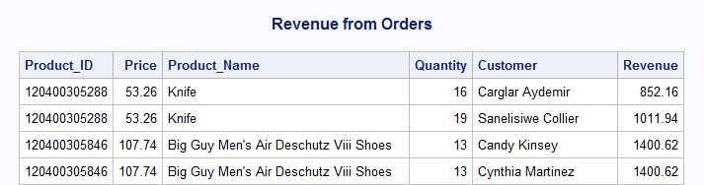

1 b)

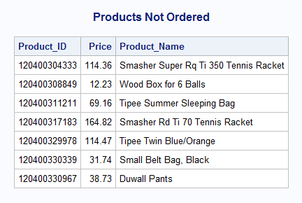

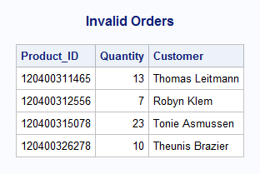

2 a)

**data** web_converted(drop=nProduct_ID);

length Product_ID $ **12**;

set orion.web_products2(rename=(Product_ID=nProduct_ID));

Product_ID=put(nProduct_ID,**12.**);

**run**;

NOTE: There were 20 observations read from the data set ORION.WEB_PRODUCTS2.

NOTE: The data set WORK.WEB_CONVERTED has 20 observations and 3 variables.

NOTE: DATA statement used (Total process time):

real time 0.02 seconds

cpu time 0.01 seconds

2 b)

**data** revenue

NotSold(keep=Price Product_ID Product_Name)

InValidCode(Keep=Product_ID Quantity Customer);

merge web_converted(in=InConv rename=(Name=Product_Name))

orion.web_orders2(in=InOrders rename=(Name=Customer));

by Product_ID;

if InConv and InOrders then do;

Revenue = Quantity * Price;

output revenue;

end;

else if InConv and not InOrders then output notsold;

else if not InConv and InOrders then output invalidcode;

**run**;

NOTE: There were 20 observations read from the data set WORK.WEB_CONVERTED.

NOTE: There were 43 observations read from the data set ORION.WEB_ORDERS2.

NOTE: The data set WORK.REVENUE has 39 observations and 6 variables.

NOTE: The data set WORK.NOTSOLD has 7 observations and 3 variables.

NOTE: The data set WORK.INVALIDCODE has 4 observations and 3 variables.

NOTE: DATA statement used (Total process time):

real time 0.07 seconds

cpu time 0.00 seconds

c)

title 'Revenue from Orders';

**proc** **print** data=revenue noobs;

**run**;

title 'Products Not Ordered';

**proc** **print** data=notsold noobs;

**run**;

title 'Invalid Orders';

**proc** **print** data=invalidcode noobs;

**run**;

title;



2 c)





**Chapter 10 Level I and II Exercises**

1 a)

**data** continent;

keep Start Label FmtName;

retain FmtName 'continent';

set orion.continent(rename=(Continent_ID=Start Continent_Name=Label));

**run**;

NOTE: There were 5 observations read from the data set ORION.CONTINENT.

NOTE: The data set WORK.CONTINENT has 5 observations and 3 variables.

NOTE: DATA statement used (Total process time):

real time 0.01 seconds

cpu time 0.01 seconds

1 b)

**proc** **format** library=orion.MyFmts cntlin=continent fmtlib;

select continent;

title 'Continent format';

**run**;

NOTE: PROCEDURE FORMAT used (Total process time):

real time 0.05 seconds

cpu time 0.03 seconds

NOTE: Non-portable document will be produced. The current settings of

FORMCHAR use nonstandard line-drawing characters and the resulting

output file will not render correctly unless all readers of the

document have the SAS Monospace font installed. To make your document

portable, issue the following command:

OPTIONS FORMCHAR="|----|+|---+=|-/\<>*";

NOTE: There were 5 observations read from the data set WORK.CONTINENT.

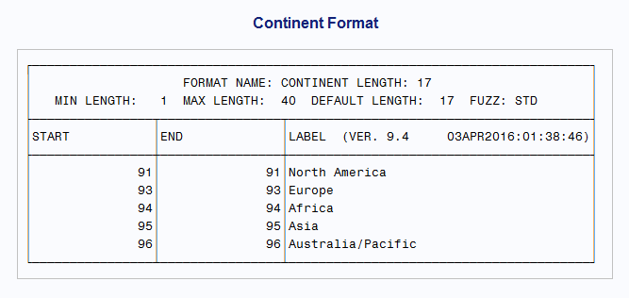

c)

options fmtsearch=(orion.MyFmts);

**data** countries;

set orion.country;

Continent_Name=put(Continent_ID, continent.);

**run**;

**proc** **print** data=countries(obs=**10**);

title 'Continent Names';

**run**;

title;

1 c)

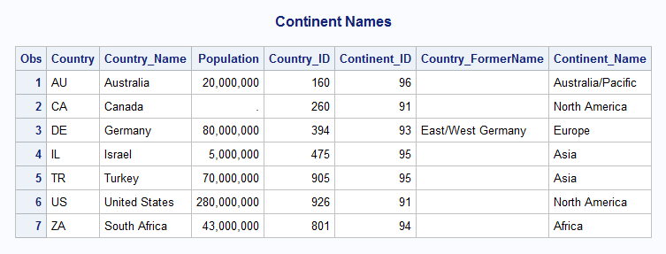

d)

**proc** **format** library=orion.Myfmts cntlout=continentfmt;

select continent;

**run**;

**data** continentfmt;

set continentfmt orion.NewContinent;

**run**;

**proc** **format** library=orion.Myfmts cntlin=continentfmt fmtlib;

select Continent;

title 'Continent Format (Updated)';

**run**;

title;

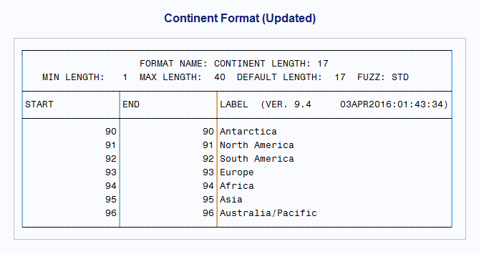

2 a)

**data** ages;

set orion.ages(rename=(First_Age=Start Last_Age=End Description=Label));

retain FmtName 'ages';

**run**;

NOTE: There were 4 observations read from the data set ORION.AGES.

NOTE: The data set WORK.AGES has 4 observations and 4 variables.

NOTE: DATA statement used (Total process time):

real time 0.01 seconds

cpu time 0.00 seconds

**proc** **format** library=orion.MyFmts fmtlib cntlin=ages;

select ages;

**run**;

NOTE: PROCEDURE FORMAT used (Total process time):

real time 0.44 seconds

cpu time 0.10 seconds

NOTE: Writing HTML Body file: sashtml26.htm

NOTE: There were 4 observations read from the data set WORK.AGES.

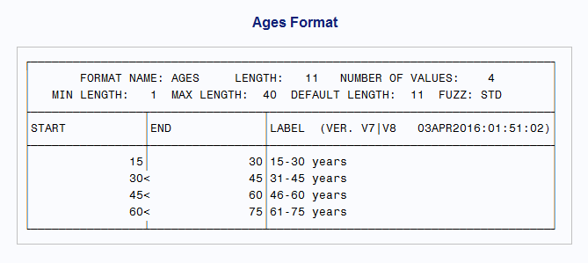

b)

options fmtsearch=(orion.MyFmts);

**data** sales;

set orion.sales(keep=Employee_ID Birth_Date);

Age=int(yrdif(Birth_Date, today(), 'AGE'));

Age_Cat=put(Age, ages.);

**run**;

2 b)

NOTE: There were 165 observations read from the data set ORION.SALES.

NOTE: The data set WORK.SALES has 165 observations and 4 variables.

NOTE: DATA statement used (Total process time):

real time 0.07 seconds

cpu time 0.00 seconds

c)

options nodate nonumber;

**proc** **print** data=sales(obs=**5**);

format Birth_Date date9.;

title 'Sales Data Set';

**run**;

title;

NOTE: There were 5 observations read from the data set WORK.SALES.

NOTE: PROCEDURE PRINT used (Total process time):

real time 0.49 seconds

cpu time 0.15 seconds

